**Intestinal Worms Final Technical Report**

Global Solutions VIP

Team Members:

Anna Hart

Nathaly Jose-Maria

Shinhaeng Lee

Chenyu Li

ADVISORS:

Dr. James Stubbs, PhD

Dr. Kelsey Kubelick, PhD

Lucia Coco, TA

**Executive Summary**

The purpose of our project is to improve diagnosis of soil transmitted helminth in under-resourced global communities. In doing so, communities will receive more effective treatment and move towards the goal of eliminating child mortality from soil transmitted helminth. To achieve this goal, our team aims to reduce the amount of technical labor needed to diagnose soil transmitted helminth infections. Our solution must detect the presence, species, and number of intestinal worm eggs with sufficient accuracy and efficiency [4,5]. Our team aims to produce a machine learning model which can effectively classify the number and type of worm eggs, run based off of standard microscope images, and is robust to noise [4,5]. This semester, our team worked towards creating a dataset with which we can train our machine learning model. To do this, we created artificial stool samples, using glitter as worm eggs, and imaged them with a standard laboratory microscope. We researched various machine learning algorithms, and going forward aim to try the machine learning algorithms on our dataset to determine the best techniques for counting the number of eggs in our samples.

**Introduction**

Our project focuses on mitigating the impact of intestinal worms on children in regions with endemic soil transmitted helminth (STH) infections [4,5]. STH infections pose particular risks to the health of children and pregnant mothers and affects over a billion people worldwide [4,5]. The World Health Organization treats STH as a widespread community issue when more than 2% of the population has a moderate or severe STH infection [4,5]. In order to determine where to allocate resources and administer deworming medications to combat STH, workers need an efficient, effective way to determine which communities meet this benchmark [4,5]. Four major species of STH are of primary concern: roundworms, whipworms, threadworms, and hookworms [7]. While there are many methods of analyzing stool samples, and methods like PCR have shown a slightly better diagnostic accuracy according to some studies, those methods require increased equipment costs, and the Kato-Katz remains the “WHO golden standard” [12]. Currently, the Kato-Katz technique manually processes and counts the number of worm eggs present in stool samples of the community; however, this requires long hours of skilled labor [4,5]. Collecting and processing the data is cited as the most time consuming step, and we seek to minimize this through a more efficient and automated sampling and analysis technique [18]. Through discussion with Capstone, we learned a previous Capstone team created a 3D-printed device with an installed microscope through which the users can take pictures of stool slides in the box; thus, we aim to further decrease the technical effort required by creating an automated STH diagnosis system with machine learning. Children Without Worms operates in Uganda, Bangladesh, and Kenya [4,5]. The problem space is further complicated by a lack of reliable electricity, transportation, and laboratories in these communities [9]. A reliable, efficient, and standardized method of quantifying STH infection using stool samples is necessary to make critical decisions regarding de-worming medication and allocation of resources in these communities [4,5, 13].

**Description of Project Goals and Scope**

In order for our solution to be successful, the machine learning model needs to accurately count the number of eggs within a stool sample, determine the species of the eggs, and based on that information, classify the severity of the infection [4,5]. Our current proposed solution is to process stool samples using Kato Katz, then image the samples with a basic microscope, upload the images to the cloud, analyze the images with a machine learning model, and relay the results back to the team in a user-friendly interface.

Through a meeting coordinated with the Capstone Team, we gained access to 3-D printed prototypes of a manual machine for fecal slide imaging, lighting, microscopy options for slide imaging, sample slides of fake stool, and materials for making fake stool. A recently published video on current research conducted by Johnson & Johnson regarding egg-counting served as inspiration [7]. From here, we named two specific goals for our machine learning algorithm research: that we can efficiently improve the image quality from noisy microscope images and that our algorithm can effectively count and classify the worm eggs.

This semester, our goal has been to curate a dataset of samples for the machine learning model to learn from, due to an unavailability of open-source databases of intestinal worm samples in order for the team to train the machine learning model. As a solution, we created and imaged artificial stool samples; furthermore, we are obtaining real stool slides from partners and aim to compile images into a defined dataset this semester. The team has also continued identifying which machine learning techniques may be the best options for our use case as well as image preprocessing techniques in order to increase the consistency of our model. Overall, our goal this semester is to have a robust dataset, sufficient research into machine learning algorithms that we can begin to prototype our machine learning model, and a software development environment for our team. This will help teams in future semesters, as they will have preliminary data to begin building machine learning models, as well as the groundwork to prototype various machine learning models to classify worm eggs.

**Project Parameters**

Our solution needs to comply with all World Health organization standards, and we will measure success as such. While we may need to balance sensitivity and specificity, the World Health organization allows accuracy ranging from 60% sensitivity and 99% specificity to 86% sensitivity and 94% specificity [4,5]. Additionally, we need to maintain a low cost, ideally with equipment costs of than $1,000 [4,5]. Most importantly, our user requirements are to have a sufficiently accurate model - the details of which are described above- with less technical labor required than the current standard, Kato Katz. Our solution must be simple, robust, and accessible. Our solution will need to identify multiple species of worm eggs: namely, *Ascaris,* Hookworm, and *Trichuris,* as these are common infections in the areas Children Without Worms serves[5]*.* Moreover, our solution needs to work in areas with unreliable electricity and internet and must be usable at varying sites [5]. Our solution must be robust to variations in worm egg characteristics, debris from stool samples, and adapt to thick stool samples [5]. Ideally, our solution should be able to classify the STH infection based on three or fewer slides [5].

**Current Project Status**

One aspect of our work has focused on gathering information both about the team objective and researching potential implementations of photo-editing and egg counting algorithms. Our team produced a diagram outline of steps we will need in our algorithm (Figure 1). First - as in any machine learning algorithm - we need a dataset. For now, we will be using artificial stool samples as our dataset; soon, we will get slides from Ghent that we will be able to use as a dataset. We are likely to get 60 slides. With our artificial stool samples, we got multiple images per slide, so we are hopeful we will have sufficient data from the Ghent slides to build a dataset large enough to generate a robust prototype. Next, we will apply transformations to our images. Finally, our machine learning algorithm will need to count the number of worm eggs and then classify the worm eggs according to type [4,5].

One challenge we anticipate in our work is insufficient image quality; for example, particles in the stool could obscure the worm eggs or images could be of insufficient resolution. As such, this semester we continued research into several algorithms for image improvement.

First, the Lucy-Richardson algorithm “is one of the most commonly used procedures for image deblurring/enhancement” that looks to “reduce the homogeneity of the subregions in images” [8]. The algorithm does this with the idea of deconvolution, where the convolution between light and an original object, or the point-spread function, are estimated with the application of an inverse filter on an image in order to create the next point-spread function necessary for degranulating the original image [6].

We also looked into upscaling the resolution of images by using Super Resolution (SR) algorithms based on deep learning. In general, the deep learning technique (neural network) of SR has been trained in the way of finding the inverse function of degradation using both high-quality and low-quality image data [10], and there are many different types of the techniques to solve the task. The first super resolution algorithm, SRCNN, consists of three convolution networks in the way of a simple CNN architecture: patch extraction and representation, non-linear mapping, and reconstruction [10]. In the first step of this technique, the image is upscaled to a higher resolution, and then it passes through the first convolution networks, which is the patch extraction and representation. The mean of each patch (a group of image pixels) is removed from each pixel’s value and represents them using some filters. The next layer, which is the non-linear mapping layer, is made of convolutional filters for revising the number of channels and adding non-linearity, and, for the last one, the final reconstruction network is used for reconstructing the high-resolution image [10]. Second, EDSR is a well-performing and popular super resolution algorithm. It consists of multiple residual blocks and is like the SRResNet architecture, but the Batch Normalization layers (BN) are not included in the EDSR architecture [10]. Since BN normalizes the intermediate features, there is a limitation on flexibility of the network, and it causes decreasing accuracy and takes about 40% of memory usage [10]. Instead, it utilizes constant scaling layers to make the networking training more efficient [10].

For image detection, we first researched Two-Stage/Proposal algorithms and One-Stage/Proposal-Free algorithms [2]. The two-stage algorithms break steps down into two stages; one is detecting possible regions of the objects, and the other one is classifying the image in those regions into object classes [2]. These algorithms are relatively slower than the one-stage algorithms. So, YOLO, which is the most popular one-stage algorithm, was a great target to start the research about various types of image detection algorithms. The YOLO algorithm is a much faster image detection algorithm than any other algorithms since it uses an end-to-end neural network, which brings about predictions of bounding boxes and class probabilities all at once [2]. But there are some limitations for the YOLO algorithm, and one of them is that the accuracy of image detection decreases as the object size decreases. But, while the images are going through the SR process before they come to the image detection steps, the over size of images would be increased with their resolutions, so the limitation is not considered as a big deal right now [2].

Additionally, one of our team members looked into the features of Photoshop on his personal computer; he found features such as the ability to change image resolution, which could be useful (Figure 6).

We additionally found a machine learning algorithm that performed many different pre-processing steps [19]. First, the model used principal component analysis (PCA) to extract the most meaningful features from the image - thus making the model more lightweight and effective. The algorithm also used contour and edge detection to segment out the eggs from the background. Namely, they used contour detection to segment the image, and multi-scale wavelet detection for edge detection [19]. These are important pre-processing techniques for us to try when we begin building and testing a machine learning model.

In finding machine learning algorithms that could meet our objectives, we found an article on counting nematode eggs infesting soybean yields detailing a technical procedure nearly matching our goal of distinguishing these eggs from other particles in its surroundings [1]. Their approach was described as creating a network with layers of many images overlapping in order to create metadata from aggregated regions in the images indicating whether or not an egg was present in the subsection pictured [1]. We found a way to access their code to research and edit for our needs and plan to continue future work this semester by further exploring this implementation.

We then found an article in which the researchers used an improved version of R-CNN, Faster R-CNN, in worm egg detection. A representation of this algorithm is found in Figure 7. This method has proven accuracy and efficiency in processing the data [21].

Likewise, one last approach we plan on exploring for egg-counting is researching circular object detection algorithms. A specific source currently being explored mentions methods of cleaning an image with contrasts to create an outline of the circular object and an area of dense pixel concentrations for counting [17]. Moving forward with this knowledge, we plan on continuing to research specifically the code found with the nematode egg study and the noted circular detection algorithm in hopes of combining the two to create the codical solution we are looking for.

Also, we began looking into the feasibility of deploying a machine learning model in the field. We did some research into machine learning computing platforms on mobile devices. Convolutional neural networks for image analysis consume a significant amount of memory space; however, there are techniques being developed to compress the algorithms [22]. Potential options include compressing the algorithm, choosing small algorithms, re-using intermediate results, and increasing the efficiency of matrix operations. While we will strive to create the model to be as lightweight as possible, having the model execute solely on a mobile device will restrict the types of algorithms we can run and likely decrease the quality of our model. Thus, we should investigate cloud based platforms in order to decrease the restrictiveness of the available computing power [22].

Notably, this semester we produced an artificial stool sample dataset, building off of last semester's work. We followed the procedure detailed in "Review of synthetic human faeces and fecal sludge for sanitation and wastewater research", with slight modifications [14]. The procedure involved combining baker's yeast (for which we substituted brewer's yeast), microcrystalline cellulose, psyllium husk, various salts, oleic acid, yeast extract, miso paste, and water. The procedure indicated a wait time of 90 minutes; however, this was primarily for the yeast to produce gas for the stool to float. Since we did not need the stool to float, and due to time constraints, we forewent the wait step. Additionally, we only added in 50% water content, as the stool did not have as much time to sit and soak in the water due to time constraints. We believe this will not substantially hinder our model, as the artificial stool samples are far from real samples to begin with, and stool has natural variation [14]. We added glitter as worm eggs, at the advice of last year's capstone team, which have a hexagonal shape. In order to create variation in the samples, we had two pairs of members produce the stool samples and images separately to create a more robust dataset. In total, we have 100 images of stool with glitter (worm eggs), and 100 images of stool without glitter as our control. A sample of images are included below in Figure 2. This helps us achieve our goal of having a dataset with which to prototype our machine learning algorithm.

Currently, we are also in the process of researching the effectiveness of Google Colab as a shared workspace. Also, we are writing code to build a demo version of the SR in Google Colab and are currently in the process of resolving computing errors. We will check which algorithms are best for our case by running some demo versions of each algorithm and train the algorithms we choose by using the data sets we found. A demoed version of EDSR with our fake stool samples can be seen in Figure 5.

Overall, our work has produced an understanding of several machine learning algorithms and image processing techniques which will aid us in achieving our goal of prototyping a machine learning model. Furthermore, we now have a working artificial dataset with which to begin prototyping our machine learning solution. However, we still may face challenges with access to code from the papers we researched, as well as issues translating a model built on the artificial samples to real samples.

**Team Status**

Our team has many different noteworthy strengths. Nathaly has experience programming in various languages, particularly Python for data processing, Java for ubiquitous computing, SQL for data management, and modeling particularly with Unity. Anna has experience with computer vision algorithms, as well as an understanding of the project background from last semester. Shinhaeng is currently studying computer science as a junior. He is quite familiar with Java and C++ and has some experience with PyTorch and Linux OS. Chenyu is a ChBE freshman. He can help the team with experiment and product design. Our team has been effective in communication, and takes the time to share knowledge and understanding of concepts with each other.

Likewise, we have deficiencies that we acknowledge and actively assist each other in improving. Since the majority of our team are CS majors, we may lack the background knowledge of STH and experience in the lab. For example, we took the time to become oriented to the lab when creating our artificial stool samples. Furthermore, when we begin working with true worm egg samples, we may face difficulty in understanding the clinical features of different worm egg infections that are needed to label our data when training our model.

**Proposed Schedule:** see Figure 8.

**Conclusion**

Overall, we have created a prototype dataset and an understanding of machine learning algorithms so that next semester the team can prototype a machine learning algorithm for classifying STH infections. Our overarching solution aims to impact global health by increasing the efficiency of STH diagnosis in the field while minimizing the amount of human labor and time needed to make these diagnoses. Furthermore, by having an artificial intelligence solution to diagnosis, we aim to improve access to high quality diagnosis and treatments in global communities with a shortage of trained pathologists[4,5].

**Addendum**

**Figure 1: *Outline of Steps in the Machine Learning Algorithm***

| Dataset:   * Artificial Stool Samples * Worm Egg Samples from Ghent | Pre-processing:   * Can enhance images to counteract poor image quality [8]. * Can jitter images and perform train-time augmentation to build more robust dataset [3]. | Outputs:   * Number of Worm Eggs [4,5]. * Species of Worm Eggs [4,5]. |
| --- | --- | --- |

**Figure 2: *Artificial Stool Sample Images***

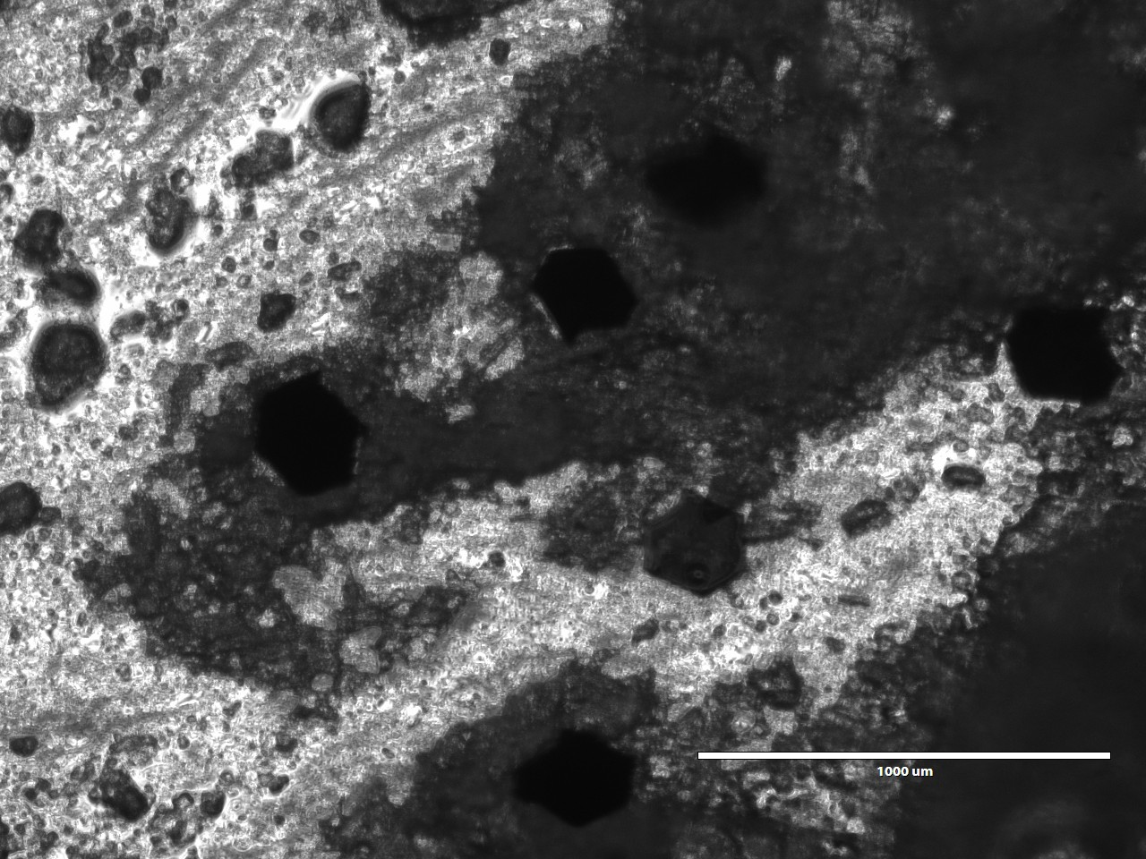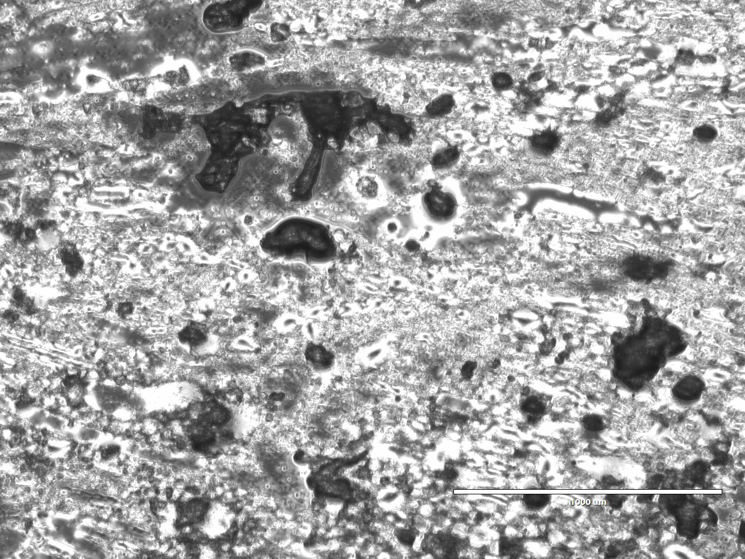

Images were taken using a microscope at magnification 10x and scale of 1000 um.

Left Image: An image of an artificial stool sample with glitter as worm eggs. The worm eggs appear with different contrasts to backgrounds, which will help our model to be more robust.

Right Image: An image of an artificial stool sample without glitter - the control. The debris in the sample will help train our model to differentiate between worm eggs and other particles which may be in stool.

**Figure 5. *EDSR Demo of Fake Stool Imaging***

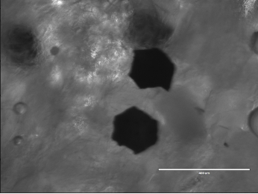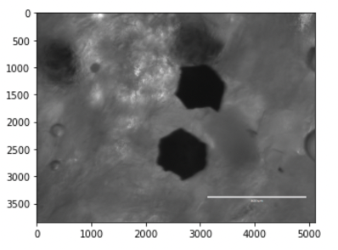

The image on the left side is a sample image from our data set, and the image on the right side is the result of running a demo version of EDSR (enhancing the resolution). We believe the resolution is a little bit increased, but because of some errors in the code, the size of the resulting image is smaller than the original one. Code sourced from [20].

**Figure 6. *Photograph Resolution Change Window***

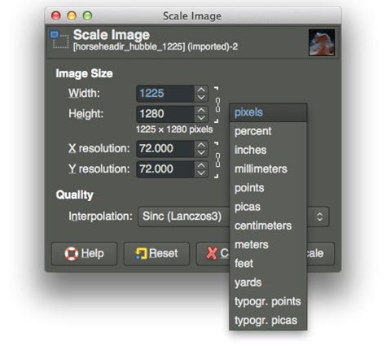

This is a screenshot from Photoshop on a Macbook personal computer taken by one of our own members.

**Figure 7. *Faster-RCNN architecture for worm egg detection***

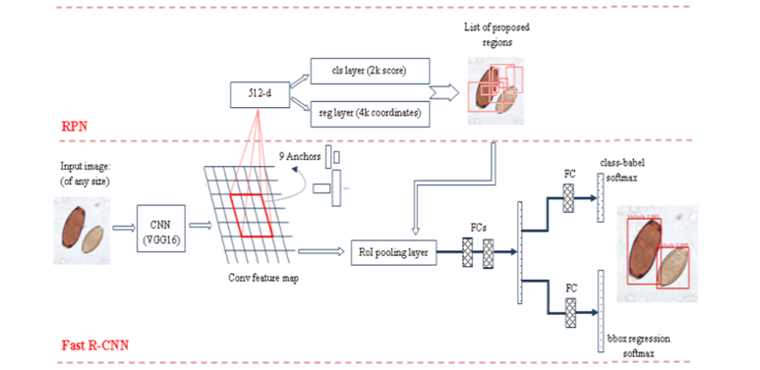

Image sourced from [21].

**Figure 8. *Potential Schedule upon Return from Spring Break***

| Mon. March 28 - Sun. April 3 | Start applying image resolution algorithms we have been researching on our fake stool data set. |
| --- | --- |
| Mon. April 4 - Sun. April 10 | Continue application of image resolution algorithms while having other members of the team concurrently working on testing egg-count or similar object-detection algorithms on the fake stool data set. |
| Mon. April 11 - Sun. April 17 | Continue practice and application with both algorithm types. |
| Mon. April 18 - Wed. April 26 | Wind down research and prepare offboarding materials noting where research has paused in preparation for Summer Break. |
| Subsequent Semesters | Upon receiving real stool samples here at the university, further develop our algorithms by testing them against real stool data sets to better train the machine learning involved. |

**References**

[1] Akintayo, A., Tylka, G.L., Singh, A.K., Ganapathysubramian, B., Singh, A., & Sarkar, S. (2018). A deep learning framework to discern and count microscopic nematode eggs. *Sci Rep* 8, 9145. <https://doi.org/10.1038/s41598-018-27272-w>

[2] Bandyopadhay, H. (n.d.). *Yolo: Real-time object detection explained*. V7. Retrieved March 17, 2022, from https://www.v7labs.com/blog/yolo-object-detection

[3] Brownlee, J. (3 May 2019). "Best Practices for Preparing and Augmenting Image Data for CNNs." Machine Learning Mastery. https://machinelearningmastery.com/best-practices-for-preparing-and-augmenting-image-data-for-convolutional-neural-networks/

[4] Children Without Worms (27 May 2021). "Innovative Technology to Address the Elimination of Morbidity of Soil Transmitted Hemelinth."<https://gatech.instructure.com/courses/214292/files/24538503?module_item_id=1970154>

[5] Children Without Worms (2021). "Welcome Georgia Tech BME Students!" <https://gatech.instructure.com/courses/214292/files/24797641?module_item_id=1982086>

[6] Fish, D. A., Brinicombe, A. M., Pike, E. R., & Walker, J. G. (1995). "Blind deconvolution by means of the Richardson–Lucy algorithm," J. Opt. Soc. Am. A 12, 58-65.

[7] Greco, B., Nogaro, S., & Stuyver, L. [The International Society for Neglected Tropical Diseases]. (2021, Jan 29). Access to schistosomiasis innovation: the next frontier to reach elimination by 2030. [Video]. YouTube.https://www.youtube.com/watch?v=jguh-vzdkQM.

[8] Hojjatoleslami,S. A., Avanaki, M. R. N. & Podoleanu, A. Gh. (2013). "Image quality improvement in optical coherence tomography using Lucy–Richardson deconvolution algorithm," Appl. Opt. 52, 5663-5670 (2013)

[9] Jain, Manav, Keith, Emily, et, al. (28 September 2021) “Design Inputs Report, Paradigm” Georgia Institute of Technology.

[10] Matcha, A. C. N. (2021, April 9). *A review of Image Super-resolution*. Paperspace Blog. Retrieved March 17, 2022, from https://blog.paperspace.com/image-super-resolution/

[11] Mathworks. (n.d.). *Deblurring Images Using the Lucy-Richardson Algorithm.* Mathworks. https://www.mathworks.com/help/images/deblurring-images-using-the-lucy-richardson-algorithm.html.

[12] Mbong Ngwese, M., Prince Manouana, G., Nguema Moure, P. A., Ramharter, M., Esen, M., & Adégnika, A. A. (2020). Diagnostic techniques of soil-transmitted helminths: Impact on control measures. *Tropical Medicine and Infectious Disease*, *5*(2), 93.

[13] Narut Butploy, Wanida Kanarkard, Pewpan Maleewong Intapan, "Deep Learning Approach for Ascaris lumbricoides Parasite Egg Classification", *Journal of Parasitology Research*, vol. 2021, Article ID 6648038, 8 pages, 2021.<https://doi.org/10.1155/2021/6648038>

[14] Penn, Roni, Barbara J. Ward, Linda Strande, Max Maurer, Review of synthetic human faeces and faecal sludge for sanitation and wastewater research,Water Research,Volume 132, 2018,Pages 222-240

[15] Photoworks. (n.d.) *How to Sharpen a Blurry Photo?* Photoworks.<https://photo-works.net/how-to-sharpen-blurry-photo.php>.

[16] Scikit-image. (n.d.). *Image Deconvolution*. Scikit-image. https://scikit-image.org/docs/dev/auto_examples/filters/plot_deconvolution.html.

[17] Smereka, M. & Dulęba, I. (2008). “Circular Object Detection Using a Modified Hough Transform.” *International Journal of Applied Mathematics and Computer Science*, 18(1) 85-91. <https://doi.org/10.2478/v10006-008-0008-9>

[18] Stuyver LJ, Levecke B (2021) The role of diagnostic technologies to measure progress toward WHO 2030 targets for soil-transmitted helminth control programs. PLOS Neglected Tropical Diseases 15(6): e0009422.<https://doi.org/10.1371/journal.pntd.0009422>

[19] Tchinda, Beaudelaire Saha, Michel Noubom, Daniel Tchiotsop, Valerie Louis-Dorr, Didier Wolf (2019). *Towards an automated medical diagnosis system for intestinal parasitosis.* Informatics in Medicine Unlocked, Volume 16, 2019, 100238, ISSN 2352-9148, https://doi.org/10.1016/j.imu.2019.100238.

[20] Tagadiya, S. (2021, February 4). Image super-resolution using EDSR and WDSR. Medium. Retrieved March 17, 2022, from https://medium.com/mlearning-ai/image-super-resolution-using-edsr-and-wdsr-f4de0b00e039

[21] Viet, N. Q., ThanhTuyen, D. T., & Hoang, T. H. (2019, January). Parasite worm egg automatic detection in microscopy stool image based on Faster R-CNN. In *Proceedings of the 3rd international conference on machine learning and soft computing* (pp. 197-202).

[22] Wang, Yingchun, Jingyi Wang, Weizhan Zhang, Yufeng Zhan, Song Guo, Qinghua Zheng, Xuanyu Wang, A survey on deploying mobile deep learning applications: A systemic and technical perspective, Digital Communications and Networks, Volume 8, Issue 1,2022, Pages 1-17, ISSN 2352-8648. <https://doi.org/10.1016/j.dcan.2021.06.001>.